**DAILY ONLINE ACTIVITIES SUMMARY**

|  |  |  |  |  |  |  |  |  |
| --- | --- | --- | --- | --- | --- | --- | --- | --- |
| **Date:** | **18/05/2020** | | | | | **Name:** | **Chandana Patil** | |
| **Sem & Sec** | **6th Sem and A Sec** | | | | | **USN:** | **4AL17CS020** | |
| **Online Test Summary** | | | | | | | | |
| **Subject** | | **Cryptography Network Security & Cyber Laws** | | | | | | |
| **Max. Marks** | | **60** | | **Score** | | | **41** | |
| **Certification Course Summary** | | | | | | | | |
| **Course** | **Machine Learning for Apps** | | | | | | | |
| **Certificate Provider** | | | **Alison** | | **Duration** | | | **6-7 Hours** |
| **Coding Challenges** | | | | | | | | |
| **Problem Statement:**  **1.** Using methods charAt() & length() of String class, write a program to print the frequency of each character in a string.    **2.** Write down a java program to print even and odd numbers series respectively from two threads: t1 and t2 synchronizing on a shared object Let t1 print message “ping — >” and t2 print message “ ,—-pong”. | | | | | | | | |
| **Status: Completed** | | | | | | | | |
| **Uploaded the report in Github** | | | | | **yes** | | | |
| **If yes Repository name** | | | | | **https://github.com/chandanapatil/OnlineCourse.git** | | | |
| **Uploaded the report in slack** | | | | | **Yes** | | | |

**Online Test:**

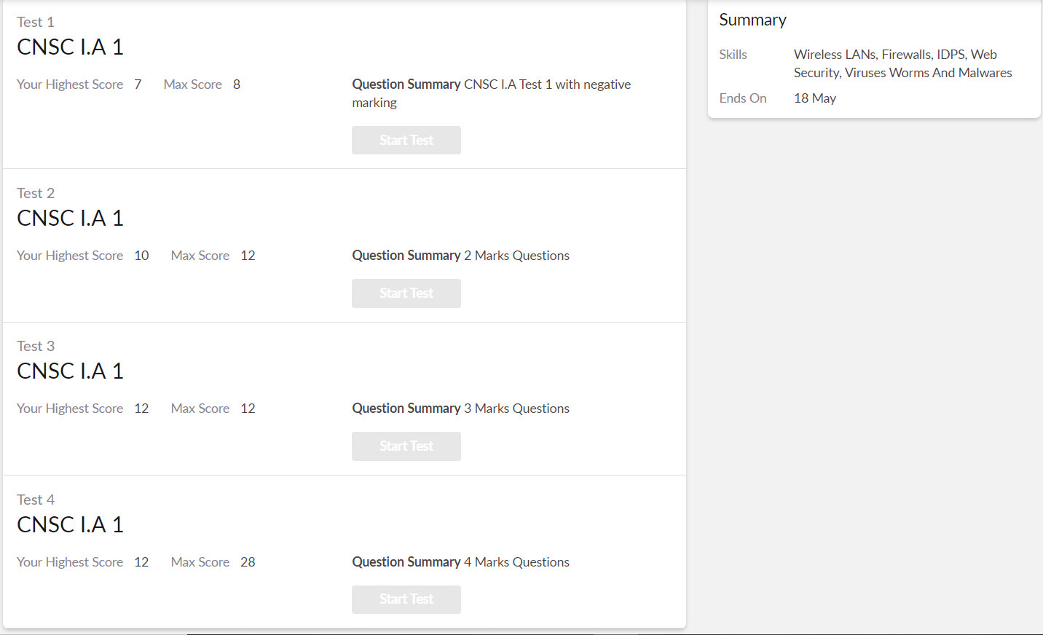

**Certification: These are the completed topics**

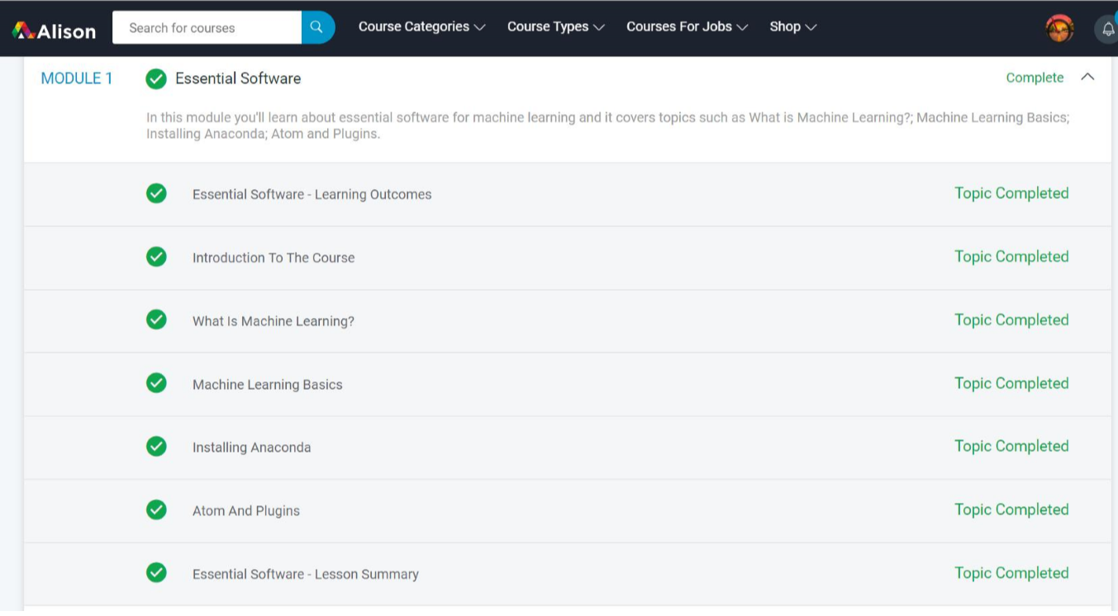

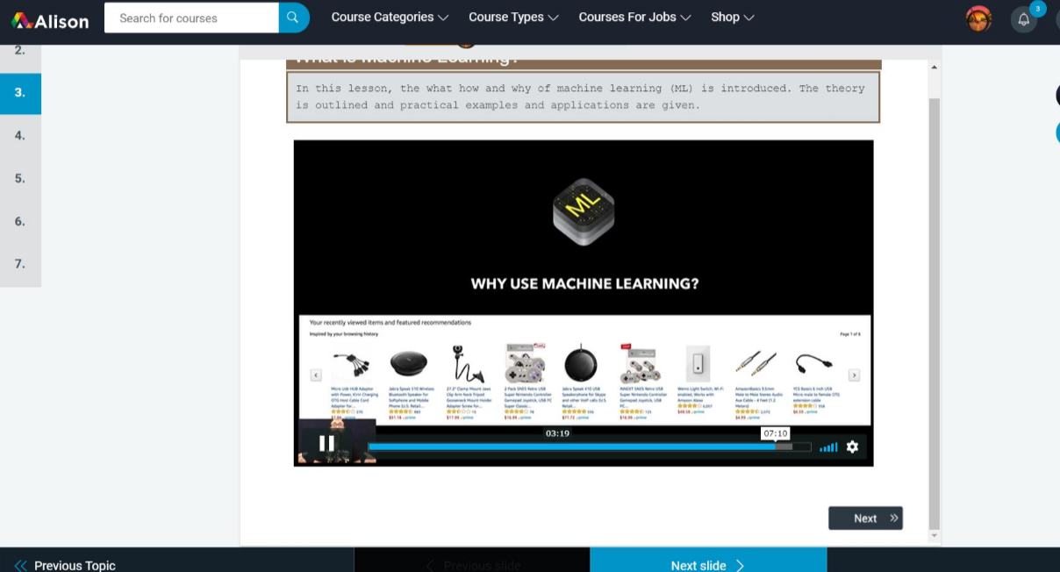

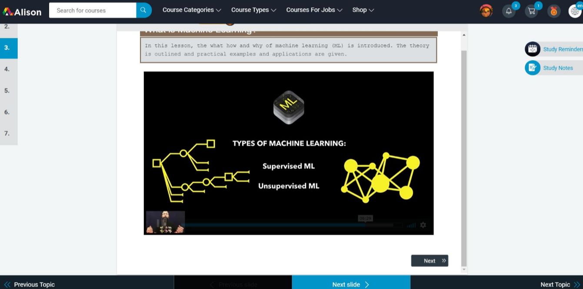

**OnlineCoding:**

**Prog1:** Using methods charAt() & length() of String class, write a program to print the frequency of each character in a string.

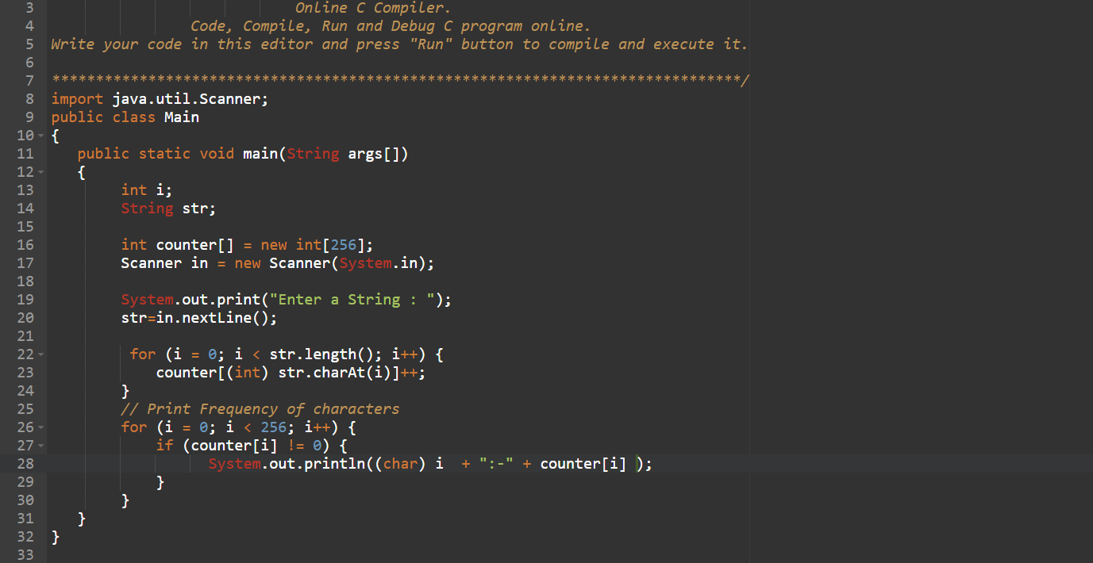

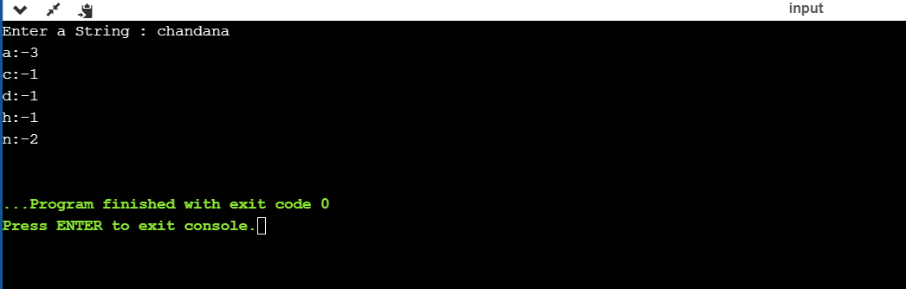

**Prog2:** Write down a java program to print even and odd numbers series respectively from two threads: t1 and t2 synchronizing on a shared object Let t1 print message “ping — >” and t2 print message “,—-pong”.

